Workesheet 1
Page 1
1)

2 & 3

4)
Definition |  |  | Computation |  |  | Plot Interval |  |  | Constants
Formula for f(x) |  |  | x | f(x) |  | a | b |  | s
 | 0.1 |  | 30 | 0.004979 |  | -20 | 60 |  | t
 |  |  |  |  |  |  |  |  | u
 |  |  |  |  |  |  |  |  | v
 |  |  |  |  |  |  |  |  | w
Page 2
4) =IF(x<0,0,1/10*EXP(-x/10))

Definition |  |  | Computation |  |  | Plot Interval |  |  | Constants
Formula for f(x) |  |  | x | f(x) |  | a | b |  | s
 | 0.1 |  | 30 | 0.004979 |  | -20 | 60 |  | t
 |  |  |  |  |  |  |  |  | u
 |  |  |  |  |  |  |  |  | v
 |  |  |  |  |  |  |  |  | w
Page 3
1)
a) $63.4
b)YES
c)-4662.6
d)No. Stock price cannot be negative
2)
a) $2.85
b)$4.77
c)Answers may vary
Page 4
1)
a)$80
b)400
c)$200
d)$R\left(q\right)=200q-0.2q^{2},$ $R\left(600\right)=\$48,000$
e) $C\left(q\right)=20000+50q^{},$ $C\left(600\right)=\$50,000$
f) 300
g)$P\left(q\right)=-0.2q^{2}+150q-20000$, $P\left(500\right)=\$50,000$

Page 5
2)
a) 1000
b)$100,000
c)900 units
d)$50,000
3)
a) 200
b) $12,000
c) $consumer surplus at q=200 =\left[\int_{0}^{200}{\left(-.0005q^{2}+80\right) dq}\right]-12,000$
4)
a) 125
b) 146
c)$6.70
d)$150

Page 6
Marginal Demand, Marginal Revenue, Marginal Cost, Marginal Profit(Dinner Problem)

- What does “marginal” mean? Why do businesses use “marginal analysis”?
- refers to very small/refers to the next additional unit added to the current total
- In microeconomics Marginal Cost used to analyze the cost for an additional unit to help in capital budgeting
- If C(q) is the cost function, what is the meaning of marginal cost, MC(q)? (In words.)
- Cost for an additional dinner

- Write a formula for marginal cost in terms of C(q).
$MC\left(q\right)≈C\left(q+1\right)-C(q)$

- In the Dinners.xls example, you found that C(q) = 9000+177^(0.633) Use your answer to #3 to calculate the marginal cost if 2000 dinners are demanded. Give units with your answer and say what it means.

$MC(2000)≈\$6.88$ (cost for an additional dinner when 2000 dinners are being prepared is $6.88

- What does the answer to #4 tell you about the price you should be charging for a dinner?
Charge at least $6.88to cover the cost of the additional dinner

- What function would you need to use to find the actual price corresponding to 2000 dinners? (Name the function; but don’t do the calculation now. Try it later.
$$D\left(2000\right)=\$22.40$$
- From practical experience, do you expect MC(q) to increase or decrease as q increases? Why?
Decrease. Economies of Scale(when the average total cost falls as it increases output. )

- What is the interpretation and formula for marginal revenue, MR(q)?
$MR\left(q\right)≈R\left(q+1\right)-R(q)$

- What does tell you that MR(1124) = 14.20?
Revenue earned from an additional dinner when 1124 dinners are being prepared, is $14.20

- If you had been selling 1124 dinners and started to sell more, would you be taking in more or less money than before? (Caution: You can’t assume that the price stays the same, as it will have decreased. Use your answer to #9.)

More. Because a positive marginal revenue at 1124 means that revenue is increasing

(Marginal revenue is the derivative of the revenue function)
- When revenue function is increasing->marginal revenue function is positive
- When revenue function is decreasing->marginal revenue function is negative

- What is the interpretation and formula for marginal profit, MP(q)?
$$MP\left(q\right)≈P\left(q+1\right)-P(q)$$
- What does tell you that MP(1124) = 14.20? Do you want to increase or decrease the number of dinners you sell?

Profit earned from an additional dinner when 1124 dinners are being prepared, is $14.20.
Increase(because at 1124, profit is increasing).
- What does tell you that MP(2124) = –2.16? Do you want to increase or decrease the number of dinners you sell?
when 2124 dinners are being prepared, loss(negative profit) from an additional dinner is $2.16.
decrease(because at 2124, profit is decreasing).

- Since P(q) = R(q) – C(q), we have MP(q) = MR(q) – MC(q), What does it tell you about profit if marginal revenue is more than marginal cost? (That is MR(q) > MC(q).) What should the company do?
$MP\left(q\right)>0$-> P(q) is increasing
Make more Dinners
- What does it tell you about profit if marginal revenue is less than marginal cost? (That is MR(q) < MC(q).) What should the company do?
$MP\left(q\right)<0$-> P(q) is decreasing
Make less Dinners

- Comparing your answers to #14 and 15, what is true about MR and MC when profit is a maximum?
$$MR\left(q\right)=MC(q)$$
& $MP\left(q\right)$ should change sign from positive to negative
Page 7
Open Dinners.xls at M Cost and M Profit pages
- Review: What does “marginal profit” mean? Give definition and interpretation.
$$MP\left(q\right)≈P\left(q+1\right)-P(q)$$
- Profit earned from an additional dinner

- How do you visualize the marginal profit on the profit graph?
  - The slope of the profit graph represents the marginal profit

- Look at the profit graph. By hand, very roughly sketch a marginal profit graph.

- Look at the cost graph. By hand, very roughly sketch a marginal cost graph.

- Compare your answers to #4 with the graph shown. Why is the marginal cost function positive and decreasing everywhere?

- Marginal cost function is positive because the cost function is increasing
- Marginal cost function is decreasing because the slope of the cost function is decreasing

- Compare your answers to #3 with the graph shown. What determines where the marginal profit function is positive? Negative?
- When profit function is increasing then marginal profit is positive
- When profit function is decreasing then marginal profit is negative

Page 8
- Still looking at your answer to #3. What about the marginal profit function shows where the profit function has a maximum?

Profit maximum
Marginal profit is zero. Left of that point the marginal profit should be positive & right of that point the marginal profit should be negative

- From your answer to #3:. What about the marginal profit function shows that the profit function has a maximum, as opposed to a minimum?

Profit minimum
Marginal profit is zero. Left of that point the marginal profit should be negative & right of that point the marginal profit should be positive

- How does the marginal profit function relate to the marginal cost and marginal revenue?
$$MP\left(q\right)=MR\left(q\right)-MC(q)$$

Definition of Derivative
- How is f ‘(x), the derivative of f(x), defined?

- How do you picture f ‘(x) on a graph of f(x)?
The slope of f(x) represents the f ‘(x)
- Open Example3.xls. How are the graphs of function and derivative related?
- The derivative represents the slope of the function
- The function (blue) is increasing everywhere- >the derivative is positive(graph above the x-axis)
- From $- ∞ to 0$ the slope of the function is decreasing(the derivative function is decreasing)
- From $0 to ∞$ the the slope of the function is increasing
- At 0 the slope of the function is zero->the derivative function is zero

13)
a) increasing. MR(1000)=75, Marginal revenue is positive at 1000, therefore revenue function is increasing.
b)increasing. MP(2000)= -45, Marginal profit is negative at 2000, therefore profit function is decreasing.
c)2000
d)1400

14) -20
Page 9
15) y=0.2(x-4)+4

16)
a) -5
b)4
c)-4
d)-24

Page 10
Use Solver to find the Minimum Value of $f\left(x\right)=5x+\frac{3}{x}$ for $x>0.$

- In a spreadsheet, make computation cells to use with Solver. Input any positive value of x into a cell. Calculate the value of f(x) in a nearby cell.
For example When x=10 the function value is 50.3
- Try to minimize f(x) using Solver with a starting value of x = 200 and a constraint of x > 0. What do you observe?
Solver gives incorrect answers for the minimum value(This means that we should give a good starting value
- Graph f(x) and use the graph to pick a better starting value.
Pick any number between 0 & 2
- Run Solver again with the new starting point and find the minimum value of f(x). 7.74 At what x value does it occur? when X=0. 77

Use Solver to Find Maximum Revenue
- Let $D\left(q\right)=-0.02q+3200$. Find the quantity supplied when the price is 0.
160,000
- Find formulas for $R\left(q\right)$and $R\left(q\right)=-.02q^{2}+3200q$

- Use Solver to maximize the value of $R\left(q\right)$. What value of q makes $R\left(q\right)$ a maximum?
q=80,000 & maximum revenue 128M

- Find the value of q that makes $MR\left(q\right)=0$.
q=80,000
- What is the relationship between the values of q you found in #7 and #8?
When q=80,000, the revenue is at a maximum & marginal revenue is zero

Optimization with Constraints in Shipping.xls
- Shipping.xls contains the length, L, width, W¸ and depth, H, of a box-shaped package. Find the circumference, sum of lengths, and volume of a package measuring 40 by 15 by 10. (You don’t need Solver here, just Shipping.xls.)
Sum of lengths 65/circumference 50/volume 6000
- Use Solver to find the maximum volume given that the circumference is not above 100 and the sum is not above 120. You will need to use two constraints. Maximum volume =43750

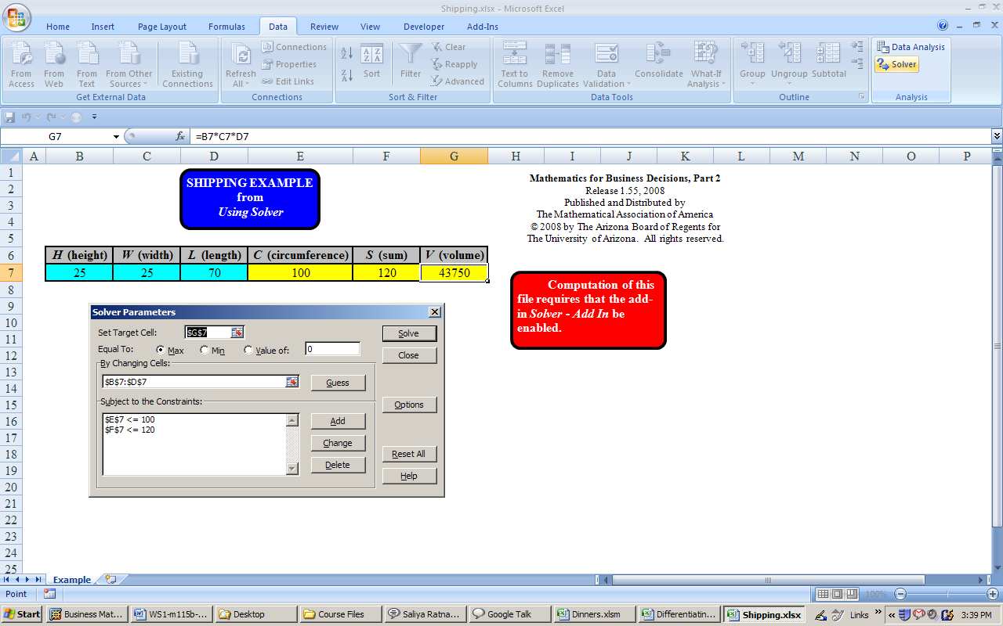

Areas Under a Curve, Consumer Demand, and Integration

Revenue and Surplus
- Using a graph of demand, how can you visualize the revenue when a quantity q is sold at a price of D(q)?
The area of the rectangle with base q and height D(q)

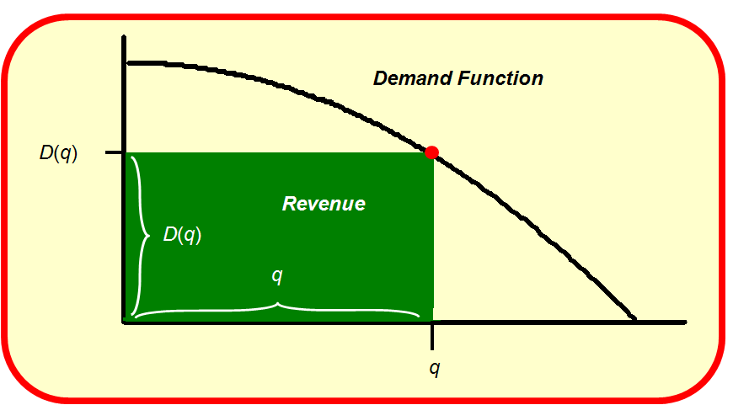
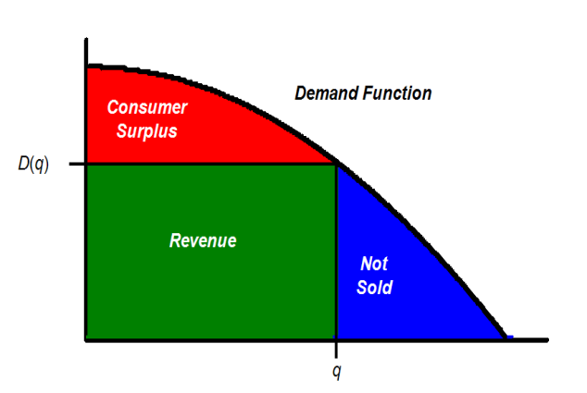

- What is meant by the total possible revenue? How do you visualize it?
The total possible revenue is the money that the producer would receive if everyone who wanted the good, bought it at the maximum price that he or she was willing to pay.

- What is meant by the consumer surplus? How do you visualize it?
The total extra amount of money that people who bought the good would have been willing to pay is called the consumer surplus
- If $D(q)=-0.01q+500$, what is the (i) Total possible revenue? 12,500,000
(ii) Consumer surplus if 20,000 items are sold? 2,000,000

Page 11

Estimating the Area Under f(x) = 2x – x²/2 over [1, 4] using Rectangles
- Graph this parabola. Label the intercepts. (Use Graphing.xls or your calculator.)

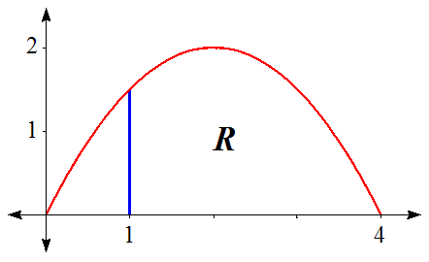

- From the diagram in PowerPoint diagram: How many rectangles are being used? This is n.
3
- What is the width of each rectangle? This is Δx.
.5
- What is the height of the first rectangle?
1.71875
- What is the area of the first rectangle?
.859375
The area under the curve is approximated by the sum of the areas of the rectangles. This approximation gets better as n increases. The file Area Example.xls calculates the sum S_{n} for any value of n

- Open AreaExample.xls to the page Any n page. Enter n = 6 in the red box. The total area of the 6 rectangles is midpoint sum S₆.
4.53125

- Use AreaExample.xls to find the midpoint sum for n = 10, n = 50, n = 100, n = 1000.
4.511250, 4.500450,4.500113,4.500001
- What do your answers to Question #11 tell you about the area under the curve?
4.5
Estimate the Area under $f\left(x\right)=e^{-x}$ over[0, 2] using MidpointSums.xls
- Enter the function $f\left(x\right)=e^{-x}$ and the plot interval [0, 2] into Midpoint Sums.xls. Skip the computation boxes. To find the area of the rectangles, put the value of n in the red cell; the yellow cells computer automatically when you run the macro “Sum”. Find the area with n = 6 rectangles and n = 10 rectangles.
.86067, .86323
- In Question #13, Midpoints Sums.xls shows you a graph as well as giving you a numerical answer. What do these graphs tell you about which estimate, with n = 6 or n = 10, is closer to the true value of the area under the curve?
n=10
- With the same function, increase the value of n using the slider. What do your answers tell you about the exact value of the area under the curve?
.86466

Using Midpoint Sums for Other Examples
- Approximate the area under the curve $f\left(x\right)=ln⁡(x)$ over the interval [1,5].
4.04
- Draw a graph of the area that you have approximated in Question #16.

Page 12

Integral Notation
The area we calculated in $f\left(x\right)=e^{-x}$ over [0, 2] is represented by the integral
$$\int_{0}^{2}{e^{-x}dx}$$
We can calculate an integral by using MidpointSums.xls and increasing the value of n till the result settles down. Or we can use Integrating.xls which gives the final answer directly, having automatically taken a very large value of n.

Use Integrating.xls to calculate the following integrals:
- $\int_{1}^{5}{\ln{x}dx}$=4.0472

- $\int_{0}^{2}{x^{3}+3x^{2} dx}$=12

- $\int_{0}^{10}{x^{2}+\sqrt{x} dx}=354.415$

Consumer Surplus as an Integral: Dinners
- From the PowerPoint diagram of the demand for dinners, write an integral formula the lost revenue lost from dinners not sold.

- Write an integral formula including integrals for the consumer surplus for the diners.

- Use Integrating.xls to evaluate the integrals in Questions #21 and #22. The demand function is D(q) = −0.0000018⋅q² − 0.0002953⋅q + 30.19
Another Example
- Let $D\left(q\right)=-0.01q+5200.$ If 100,000 items are sold, find the price at which they are sold.

4200

- If the 100,000 items in Question #24 are sold, what is the consumer surplus?
50M

- Find the consumer surplus if 4000 items are sold. 4000

Page 13
27) set target cell E2
Equal to Max
By changing cells A2
Constraints
B2<=6
28)
134.88

