Name:
Part 1. Find the volume of each figure:

Hypothesis: How will the volume change with a dilation of 2 or 3?

Spheres: Volume = (4/3)πr³
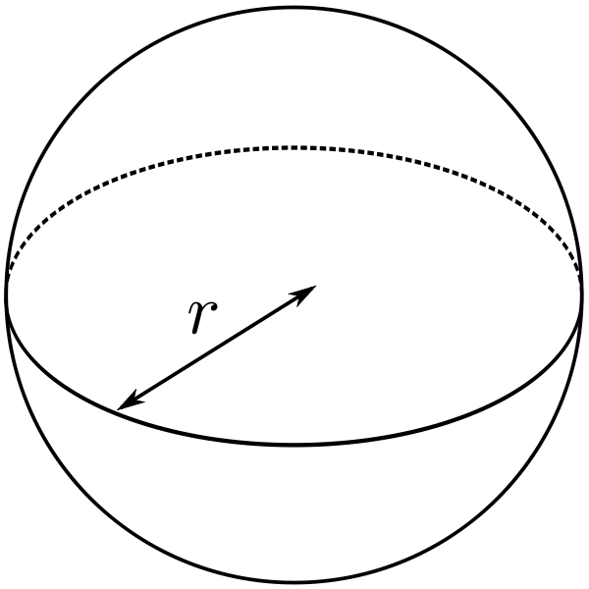
radius = 3 radius = 6 radius = 9

____________ _____ ________________ ________________

Cylinders: Volume = πr²h
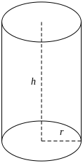
radius = 2 radius = 4 radius = 6
height = 3 height = 6 height = 9

______________ ________________ ________________

Cones: Volume = πr²h/3
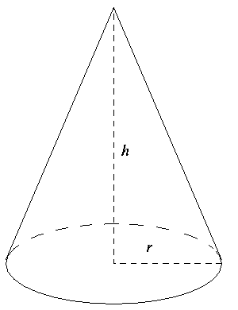
radius = 3 radius = 6 radius = 9
height = 4 height = 8 height = 12

______________ ________________ ________________
Part 2. Find the surface area of each figure:

Hypothesis: How will the surface area change with a dilation of 2 or 3?

Spheres: Surface Area = 4πr²
radius = 3 radius = 6 radius = 9

_______________ ________________ ________________

Cylinders: Surface Area = 2πrh + 2πr²
radius = 2 radius = 4 radius = 6
height = 3 height = 6 height = 9

______________ ________________ ________________

Cones: Surface Area =
radius = 3 radius = 6 radius = 9
height = 4 height = 8 height = 12

______________ ________________ ________________
Part 3. Find the surface area:volume ratio of each figure:

Hypothesis: How will the surface area:volume ratio change with a dilation of 2 or 3?

Spheres:
radius = 3 radius = 6 radius = 9

_______ _______ ________________ ________________

Cylinders:
radius = 2 radius = 4 radius = 6
height = 3 height = 6 height = 9

______________ ________________ ________________

Cones:
radius = 3 radius = 6 radius = 9
height = 4 height = 8 height = 12

______________ ________________ ________________
Images from Wikipedia, authors: Dirk Hünniger, Ævar Arnfjörð Bjarmason, and Kf
ANSWER KEY
Part 1. Find the volume of each figure:

Hypothesis: How will the volume change with a dilation of 2 or 3?
The correct answer is they will go up by 8 and 27, but as this is meant as a guess, anything should be acceptable here.
Spheres: Volume = (4/3)πr³
radius = 3 radius = 6 radius = 9

36π 288π 972π

____________ _____ ________________ ________________

Cylinders: Volume = πr²h
radius = 2 radius = 4 radius = 6
height = 3 height = 6 height = 9

12 π 96 π 324 π
______________ ________________ ________________

Cones: Volume = πr²h/3
radius = 3 radius = 6 radius = 9
height = 4 height = 8 height = 12

12 π 96 π 324 π
______________ ________________ ________________

ANSWER KEY
Part 2. Find the surface area of each figure:

Hypothesis: How will the surface area change with a dilation of 2 or 3?
They should find that it goes up by 4 and 9, but any guess is okay.

Spheres: Surface Area = 4πr²
radius = 3 radius = 6 radius = 9

36π 144π 324π
_______________ ________________ ________________

Cylinders: Surface Area = 2πrh + 2πr²
radius = 2 radius = 4 radius = 6
height = 3 height = 6 height = 9

20π 90π 180π
______________ ________________ ________________

Cones: Surface Area =
radius = 3 radius = 6 radius = 9
height = 4 height = 8 height = 12

24π 96π 216π
______________ ________________ ________________

ANSWER KEY
Part 3. Find the surface area:volume ratio of each figure:

Hypothesis: How will the surface area:volume ratio change with a dilation of 2 or 3?
They should eventually find that it goes down by ½ and 1/3, but any guess is okay.

Spheres:
radius = 3 radius = 6 radius = 9

1 ½ 1/3
_______ _______ ________________ ________________

Cylinders:
radius = 2 radius = 4 radius = 6
height = 3 height = 6 height = 9

1 2/3 5/6=.833333 5/9 = .555555
______________ ________________ ________________

Cones:
radius = 3 radius = 6 radius = 9
height = 4 height = 8 height = 12

2 1 2/3
______________ ________________ ________________
Images from Wikipedia, authors: Dirk Hünniger, Ævar Arnfjörð Bjarmason, and Kf

