Name: ____________________________________
Invasive Species Spread
Below are pictures that indicate how far the Cane Toad, Bufo marinus, has spread. It was originally introduced in 1930s to Gordonvale.
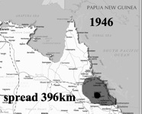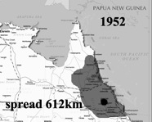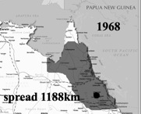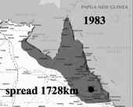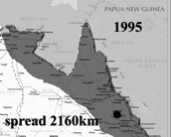
Map modified from Nation Online Project: http://www.nationsonline.org/oneworld/map/australia-map.htm; Not actual data, but close.
1) Fill in the table, using information from the pictures above.
Year
Distance spread from Gordonvale

2) Using this data, calculate the slope of a line.

3) What does the slope of this line represent, in terms of the biology of the organism?

4) Write the information in this table in slope-intercept form.

5) How far do you think the cane toads will go by the year 2025?

6) Using the data, calculate the x-intercept.

7) What does the x-intercept represent, in terms of the biology of the organism?

ANSWER KEY

Below are pictures that indicate how far the Cane Toad, Bufo marinus, has spread. It was originally introduced in 1930s to Gordonvale.
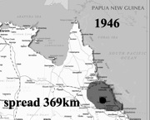
1) Fill in the table, using information from the pictures above.
Year
Distance spread from Gordonvale

2) Using this data, calculate the slope of a line.

The slope should be 36 km/year

3) What does the slope of this line represent, in terms of the biology of the organism?

It represents how fast the toads are spreading.

4) Write the information in this table in slope-intercept form.

y = 36x – 69,660

5) How far do you think the cane toads will go by the year 2025?

About 3,240 km

6) Using the data, calculate the x-intercept.

It should be 1935 (or -11 if 1946 is 0).

7) What does the x-intercept represent, in terms of the biology of the organism?
The year the toads were introduced to Australia.

