Pressure and Bernoulli’s Principle
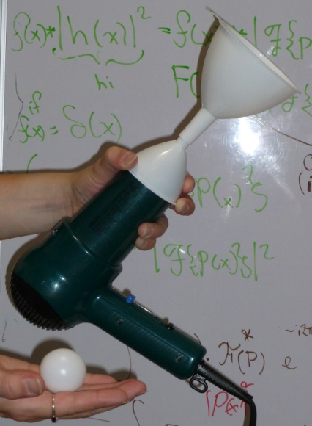
Students will explore the pressure, particularly the effects of regions of low pressure and lift. Bernoulli's principle states that an increase in the speed of the fluid occurs simultaneously with a decrease in pressure
Materials:
2 Funnels
Ping-pong ball
Hair dryer
Pinwheel
Alcohol swabs

Demo:
After a brief introduction to pressure (equations, presence of atmospheric pressure, etc.), challenge a few students (or all, if time and materials are permitting) to blow a ping-pong ball out of a funnel. Show them that there is no glue in the funnel or on the ball, because students will think it’s a trick when they can’t actually blow the ball out (mouth to bottom of funnel). For example let them blow the ball out of your hand.
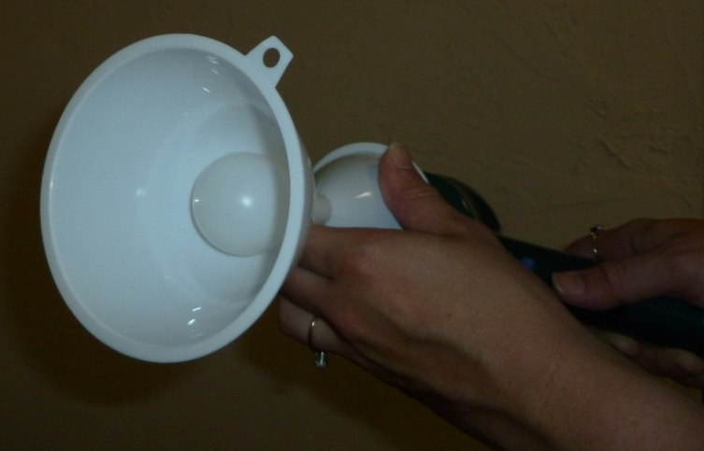
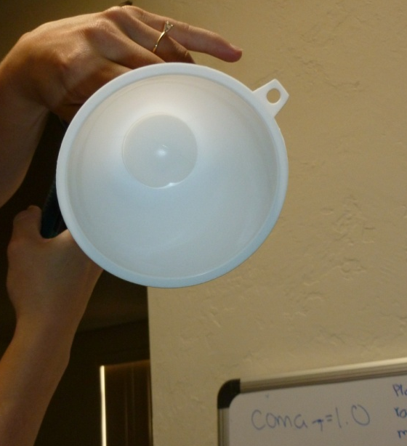
Tell students you were afraid that might happen, so you brought a hair dryer just in case. Situate funnels end-to-end (using tape or something to make sure all the air from the dryer is blowing into the top funnel), and put the ball back into the top funnel. Turn on the hair dryer (perhaps blowing it on the kids so they see it’s not sucking air…) and cover it with the bottom funnel. Magically, the ball still does not blow out of the funnel! Try tilting the whole thing so that the students see that actually the ball is being held in by the hair dryer, even though it’s blowing out. If the hair dryer is strong enough, you can actually hold the funnel up-side down without the ball falling out. When the hair dryer is turned off, the ball drops.

Discuss the idea of moving air creating low pressure: think of fast-moving air as rapidly removing air from a space. Nature abhors a vacuum, so when air is removed, something has to come in to fill the space (so removing the air is effectively creating suction). In the case of the demo, the air is moving fastest (i.e. the suction is greatest) at the base of the funnel, so the ball is the next available thing to fill the vacuum.
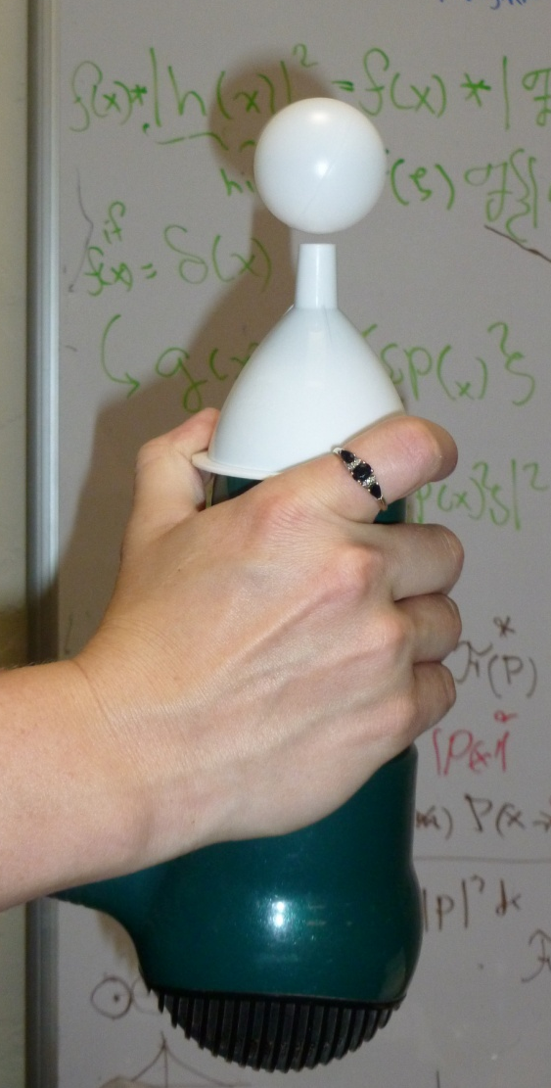
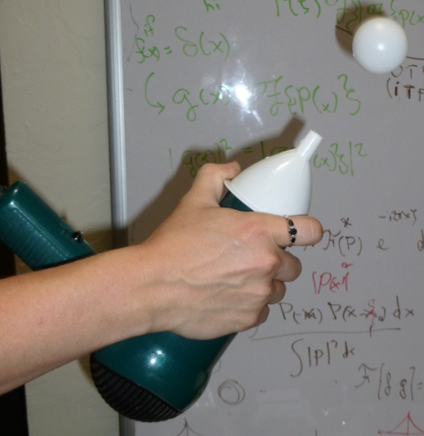
Then cover the hair dryer with one funnel and turn it on. Hold the ping-pong ball over the tip of the funnel, releasing it when it is floating stably just above the funnel. No one will be surprises. Now slowly tilt the system, showing that the ball isn’t held up from the air pushing upwards. Using a pinwheel, show that the air is in fact moving over the top of the ball. Relate this to the previous discussion on pressure and air movement.

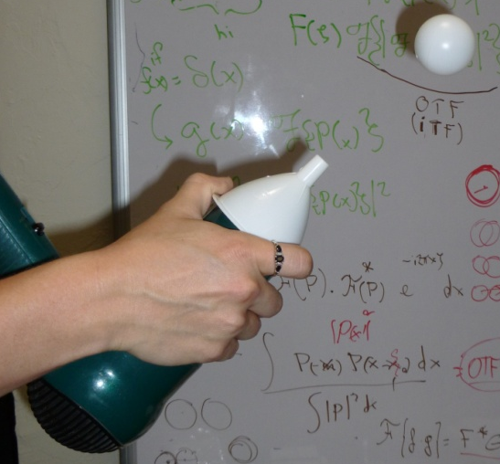

Ask students for some other examples of this principle (you’re fishing for lift in flight).

