Excel Assignment 2, Correlation and Least Squares Regression. Put problems in order, label answers (1a, etc.), do not include data or excel. Paste graphs from Excel. Provide your answers using complete sentences.
- From book problem 7.50 Change in the Serengeti. Long-term records from the Serengeti National Park in Tanzania show interesting ecological relationships. When wildebeest are more abundant, they graze the grass more heavily, so there are fewer fires and more trees grow. Lions feed more successfully when there are more trees, so the lion population increases. Here are data on one part of this cycle, wildebeest abundance (in thousands of animals) and the percent of the grass area that burned in the same year. From a graph in Craig Packer et al., “Ecological change, group territoriality, and population dynamics in Serengeti lions,” Science, 307 (2005), pp. 390–393.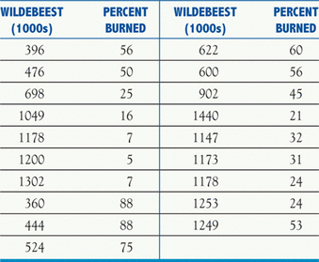
Can the number of wildebeests impact the percentage of grasslands that burn? Use the data to answer the questions below.
- What is the explanatory variable? What is the response variable? How can you tell?
- Make a scatterplot of the data (nothing else, no equations etc.) and make sure the response variable is on the vertical axis. Label the graph and label each axis appropriately and specific to this data set (do not use “Scatterplot” in labels).
- Describe the scatterplot in 2 meaningful sentences.
- Find the correlation, r, between the number of wildebeests and the percentage of grasslands that burn. Use the Excel function =correl(explanatory, response) to find this.
- What two things does the value of r found in part d tell you? Explain this in practical terms (how does the wildebeest population impact % of grasslands that burn?)
- Find the Least Squares regression equation used to predict percentage of grassland burnt based on the number of wildebeests. If you use variables (like x and y), then clearly define your variables (what does x represent, etc.)
- What is the slope of the line found in part f? What does it represent specifically in terms of this data set?
- Find r² and explain what it tells you in terms of the equation found in part f.
- Predict the % of grasslands that burn with a wildebeest input value of 400 and 1000 based on the equation found in part f.
- Is the equation found in part f a reasonable way to model (predict) the percentage of grassland burned based on the wildebeest population? Provide at least 2 reasons using specific reasoning from chapters 4 and 5.

