Type up your solutions in a word document. Label each answer accordingly (1a, etc.) Put the answer in order. Copy Excel output onto your word document. Do not include the data. You may need to refer to the matched pairs section of Chapter 20 of your ebook.
- Kicking a helium-filled football. Does a football filled with helium travel farther than one filled with ordinary air? To test this, the Columbus Dispatch conducted a study. Two identical footballs, one filled with helium and one filled with ordinary air, were used. A casual observer was unable to detect a difference in the two footballs. A novice kicker was used to punt the footballs. A trial consisted of kicking both footballs in a random order. The kicker did not know which football (the helium-filled or the air-filled football) he was kicking. The distance of each punt was recorded. Then another trial was conducted. A total of 39 trials were run. Here are the data for the 39 trials, in yards that the footballs traveled. The difference (helium minus air) is the response variable. M. B. Laferty “OSU scientist gets a kick out of sports controversy,” The Columbus Dispatch, November 21, 1993.
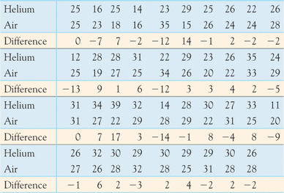
(a) This is a matched pairs test. Explain how this fits the matched pairs setting.
(b)Examine the data (the difference Air-Helium). Is it reasonable to use the t procedures? (What do you need to check to answer this? )
To help answer this, make a histogram of the data using bins of length 4 starting at -14. Include the table you used to create histogram, the histogram (bin width 0, correct title, axes labels) and answer the questions. You may need to refer to the information in chapter 20 about the “robustness of the t procedures”.
(c) Find the mean difference, the standard deviation of the difference, and the degrees of freedom for the t-test statistic.
(d)Do the data give convincing evidence that the helium-filled football travels farther than the air-filled football? To answer this, complete the following:
i. State the practical question
ii. State the null and alternative hypothesis
iii. Find the test statistic using Excel. Show your Excel output as well as indicating your final answer (the test statistic is…..)
iv. Find the pvalue of the test. What does this number mean? To answer this, look at the ebook definition of the pvalue of a test.
v. Using a significance level of α=0.5, give your conclusion in practical terms (not just reject or do not reject Ho).

With a PC, you will use this data analysis tool:
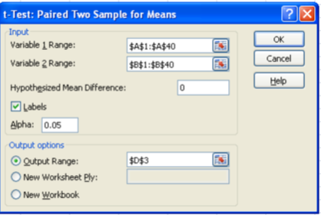

For a MAC, http://smallbusiness.chron.com/ttest-excel-mac-31904.html
Using the function: “TTEST(Array1, Array2, tails, type)”:
Drag the cursor over the first column of data beginning with cell A2. This is “Array 1.” Type a comma. The text in the cell now contains “=ttest(A2:A10."
Drag the cursor over the second column of data to add the second array. Type a comma. You now see “=ttest(A2:A10, B2:B10,” in the cell.
Type “1” or “2” for the “tail” value, then type another comma. Note that t-test “tail” refers to the tails on a line graph if the data were charted in a graph. You can use the value “1” if you are only interested in the data in one tail of the graph or “2” if both tails are important.
Type “1,” “2,” or “3” for the “type” value, then type a “)” to complete the function. Note that the t-test “type” refers to the type of t-test you want to perform. Use the value “1” to perform a paired test. Use the value “2” to use a homoscedastic t-test with a two-sample equal variance. Type the value “3” to use a heteroscedastic t-test with a two-sample unequal variance.
Press “Enter.” The function is now replaced with a value representing the result of the t-test.

