Excel Assignment 1, Chapters 1-3
Submit this assignment as a typed, professional Microsoft Word document. Do not turn in Excel spreadsheets. On graphs, and some items, you will need to copy your Excel graph, table, etc. to paste into your Word document. Do not include a copy of the data.

1 Are the data Normal? Monsoon rains. Here are the amounts of summer monsoon rainfall (millimeters) for India in the 100 years 1901 to 2000:¹⁵
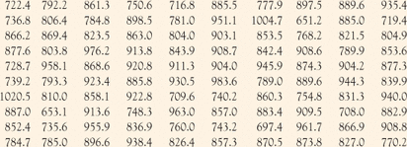
Monsoon rainfall from B. Parthasarathy, Indian Institute of Tropical Meterology, at www.iges.org. The data cover the years 1871 to 2000.
- Use Excel to find the mean, standard deviation, and 5 number summary for the amount of summer monsoons rainfall in millimeters for India. Label each answer (mean, standard deviation, etc.) and include units. Use the Excel functions below to find these values:
Mean | =AVERAGE(array) (note, MEDIAN is similar)
Median | =MEDIAN(array)
Standard Deviation | =STDEV(array)
Minimum | =MIN(array) (note, MAX is similar)
Quartile 1 | =QUARTILE(array, 1) (note, Q3 is similar)

(b) Make a histogram of these rainfall amounts. Use bins that start at 600 and increment by 50. For your answer, provide the table that was created to make the histogram as well as the histogram. Appropriately label each axis as well as the graph in terms of the data. Change the gap width to zero.
(c) Describe the histogram in at least two meaningful sentences.
(d) Although the distribution is reasonably Normal, your work on part A shows some departure from Normality. In what way are the data not Normal? HINT: Think of the shape of the normal distribution and some of the rules that you learned about it. Compare these to the histogram and the values in part a.

