Chapter 23 – Comparing Two Proportions – Class Notes
This chapter covers a two – sample problem. This means we compare two populations or responses to two treatments where the samples are independent. In Chapter 21, this comparison involved the means of the two populations. In Chapter 23 we will compare the proportion of successes in two populations.

Notation is similar to what was used in two – sample t statistics and in one – sample proportions:

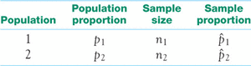

We are comparing the populations by doing inference on the difference between population proportions $(p_{1}-p_{2})$ by using the sample proportions ₁ − ₂
Example 20.1: Young adults living with parents (ages 19 to 25)
A random sample collected by the National Institute of Health included 2253 men and 2629 women. This survey found that 986 of the men and 923 of the women lived with their parents. Does this provide good evidence that different proportions of young men and young women live with their parents?

What is the null hypothesis? $H_{0}: p_{1}=p_{2}$ (the proportions are the same)
What is the alternative hypothesis? $H_{a}:{ p}_{1}≠p_{2}$ (the proportions are different so it is two – sided)
We will also find the confidence interval for the difference

${\hat{p}}_{1}=\frac{986}{2253}≈0.4376$ So 43.76% of the males in this sample live with their parents
${\hat{p}}_{2}=\frac{923}{2629}≈0.3511$ So 35.11% of the females in this sample live with their parents

(using 2 – proportion z test on calculator we get $P≈0.00000000065$which is clear evidence we should reject the null hypothesis and concluded that the proportion of young men and young women that live with their parents is different)

We now want to look at the confidence interval by finding the difference in the sample proportions:

Before continuing with this example we need to know something about the sampling distribution for the differernce in the sample proportions.

- When the sample is large, ₁ − ₂ is approximately Normal
- The mean of the sampling distribution is $p_{1}-p_{2}.$ Therefore, the differernce between the sample proportions is an unbiased estimator of the difference between popultion proportions
- The standard deviation is 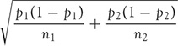
Recall that we estimate the standard deviation using the standard error of the statistic ₁ − ₂

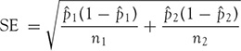
The confidence interval is the same as we have used in the previous chapter: estimate ± z*SE_{estimate}

As with the previous sections the confidence interval can be found using the calculator. Use
2 – Proportion $Z$ Interval which is in Stats under Tests.

Example 20.2 – Men versus women living with their parents

We want to find a 95% confidence interval for $p_{1}-p_{2}$, the difference between the proportions of young men and women living with their parents.

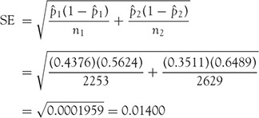

So the 95% confidence interval is

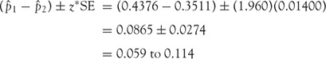

Conclusion: We are 95% confident that the percent of young men living with their parents is 5.9 and 11.4 percentage points higher than the percent of young women who live with their parents.

You should now do this computation using the calculator. $x_{1}=986, n_{1}=2253, x_{2}=923, n_{2}=2629.$ Obviously, you get the same answer and interpretation as above

PLUS FOUR CONFIDENCE INTERVAL FOR COMPARING TWO PROPORTIONS
Draw independent SRSs from two large populations with population proportions of successes p₁ and p₂. To get the plus four confidence interval for the difference p₁ − p₂, add four imaginary observations, one success and one failure in each of the two samples. Then use the large-sample confidence interval with the new sample sizes (actual sample sizes + 2) and counts of successes (actual counts + 1).
Use this interval when the sample size is at least 5 in each group, with any counts of successes and failures.
Example: Shrubs that withstand fire.
STATE: Fire is a serious threat to shrubs in dry climates. Some shrubs can resprout from their roots after their tops are destroyed. One study of resprouting took place in a dry area of Mexico.⁶ The investigators randomly assigned shrubs to treatment and control groups. They clipped the tops of all the shrubs. They then applied a propane torch to the stumps of the treatment group to simulate a fire. A shrub is a success if it resprouts. Here are the data for the shrub Xerospirea hartwegiana:
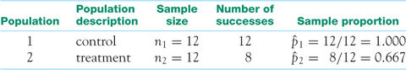
How much does burning reduce the proportion of shrubs of this species that resprout?
PLAN: Give a 90% confidence interval for the difference of population proportions, p₁ − p₂.
SOLVE: The conditions for the large-sample interval are not met. In fact, there are no failures in the control group. We will use the plus four method. Add four imaginary observations. The new data summary is
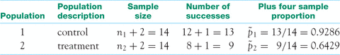
The standard error based on the new facts is
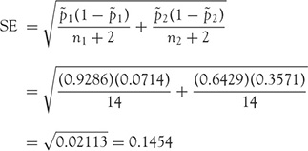
The plus four 90% confidence interval is
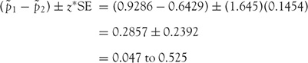
CONCLUDE: We are 90% confident that burning reduces the percent of these shrubs that resprout by between 4.7% and 52.5%.
The plus four interval may be conservative (that is, the true confidence level may be higher than you asked for) for very small samples and population p’s close to 0 or 1, as in this example. It is generally much more accurate than the large-sample interval when the samples are small. Nevertheless, the plus four interval in Example 20.3 cannot save us from the fact that small samples produce wide confidence intervals.
Significance tests for comparing proportions

Just because there is a difference between sample proportions, we cannot assume this is significant. This difference may be due to chance variation in the random sample.
To do a test, standardize the difference between the sample proportions ₁ − ₂ to get a z statistic. If H₀ is true, both samples come from populations in which the same unknown proportion p would marry someone from a lower social class. We take advantage of this by combining the two samples to estimate this single p instead estimating p₁ and p₂ separately. Call this the pooled sample proportion.
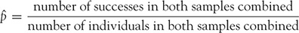
Use in place of both ₁ and ₂ in the expression for the standard error SE of ₁ − ₂ to get a z statistic that has the standard Normal distribution when H₀ is true. Here is the test.
SIGNIFICANCE TEST FOR COMPARING TWO PROPORTIONS
Draw an SRS of size n₁ from a large population having proportion p₁ of successes and draw an independent SRS of size n₂ from another large population having proportion p₂ of successes. To test the hypothesis H₀: p₁ = p₂, first find the pooled proportion of successes in both samples combined. Then compute the z statistic
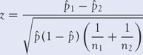

Example: Choosing a mate
STATE: “Would you marry a person from a lower social class than your own?” Researchers asked this question of a sample of 385 black, never-married students at two historically black colleges in the South. We will consider this to be an SRS of black students at historically black colleges. Of the 149 men in the sample, 91 said “Yes.” Among the 236 women, 117 said “Yes.”⁹ Is there reason to think that different proportions of men and women in this student population would be willing to marry beneath their class?
PLAN: Call the population proportions p₁ for men and p₂ for women. We had no direction for the difference in mind before looking at the data, so we have a two-sided alternative:
H₀: p₁ = p₂
H_{a}: p₁ ≠ p₂
SOLVE: The men and women in a single SRS can be treated as if they were separate SRSs of men and women students. The sample proportions who would marry someone from a lower social class are
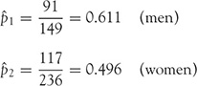
That is, about 61% of the men but only about 50% of the women would marry beneath their class. Is this apparent difference statistically significant?
SOLVE: The data come from an SRS and the counts of successes and failures are all much larger than 5. The pooled proportion of students who would marry beneath their own social class is
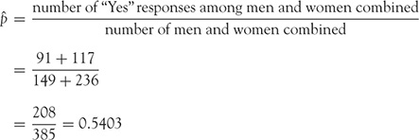

The z test statistic is
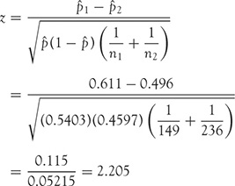
The two-sided P-value is the area under the standard Normal curve more than 2.205 standard deviations from the mean of 0. Figure 20.3 shows this area. Software tells us that P = 0.0275.
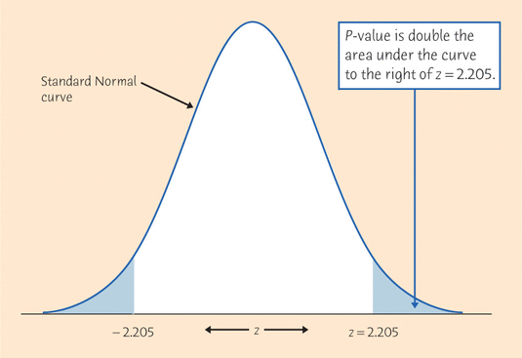

The P-value for the two-sided test of previous example

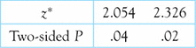
CONCLUDE: There is good evidence (P < 0.04) that men are more likely than women to say they will marry someone from a lower social class.
Broken crackers. We don’t like to find broken crackers when we open the package. How can makers reduce breaking? One idea is to microwave the crackers for 30 seconds right after baking them. Breaks start as hairline cracks called “checking.” Assign 65 newly baked crackers to the microwave and another 65 to a control group that is not microwaved. After one day, none of the microwave group and 16 of the control group show checking.⁸ Give the 95% plus four confidence interval for the amount by which microwaving reduces the proportion of checking. The plus four method is particularly helpful when, as here, a count of successes is zero. Follow the four-step process as illustrated in Example 20.3

State: How much does microwaving crackers reduce checking?

$$\hat{p_{1}}=\frac{16+1}{65+2} \hat{p_{2}}=\frac{0+1}{65+2}$$

Using 2 – proportion $Z$ interval you get $(0.13064, 0.34697)$

Interpret: There is a 95% probability that microwaving reduces checking by between 13.1% and 34.7%.

Protecting skiers and snowboarders. Most alpine skiers and snowboarders do not use helmets. Do helmets reduce the risk of head injuries? A study in Norway compared skiers and snowboarders who suffered head injuries with a control group who were not injured. Of 578 injured subjects, 96 had worn a helmet. Of the 2992 in the control group, 656 wore helmets. Is helmet use less common among skiers and snowboarders who have head injuries? Follow the four-step process as illustrated in Example 20.5. (Note that this is an observational study that compares injured and uninjured subjects. An experiment that assigned subjects to helmet and no-helmet groups would be more convincing.)

In this problem we will let $p_{1}$ represent the proportion of skiers and snowboarders who wore helmets that were injured and $p_{2}$ represent the proportion that wore helmets and were not injured. So $\hat{p_{1}}=\frac{96}{578}≈0.1161$ and $\hat{p_{2}}=\frac{656}{2996}≈0.2193$. So this says that approximately 11.61% of those that were injured wore helmets and 21.93% of those that were not injured wore helmets.

State: Is helmet use less common among skiers and snowboarders with head injuries?

$H_{0}: p_{1}=p_{2}$
$H_{a}:p_{1}<p_{2}$

Using the 2 – proportion $Z$ test, get $z=-2.855, p=0.00215$

Conclude: Since 0.215% is much less than 5%, this is strong evidence that skiers and snowboarders with head injuries are less likely to wear helmets.

