Chapter 16 – Confidence Intervals – Course Notes
Statistical inference provides methods for drawing conclusions about a population from sample data.

It should be clear that a different sample may lead to different conclusions. We will use probability to see how trustworthy our conclusions are. The most common types of inference are confidence intervals for estimating the value of a population parameter and tests of significance for assessing the evidence for a claim about a population. In chapter 14 you will learn about confidence intervals and in chapter 15 you will learn about tests of significance.

Note: In chapters 14 and 15 we are assuming that we have a perfect SRS, the population has a normal distribution and that the population standard deviation ($σ$) is known. These are not terribly realistic assumptions. In subsequent chapters we will not make these assumptions.

Example from text on page 375:
Body mass index (BMI) is used to screen for possible weight problems. It is calculated as weight divided by the square of height, measuring weight in kilograms and height in meters. Many online BMI calculators allow you to enter weight in pounds and height in inches. Adults with BMI less than 18.5 are considered underweight and those with BMI greater than 25 may be overweight. For data about BMI, we turn to the National Health and Nutrition Examination Survey (NHANES), a continuing government sample survey that monitors the health of the American population.
Body mass index of young women: The most recent NHANES report gives data for 654 women aged 20 to 29 years.¹ The mean BMI of these 654 women was = 26.8. On the basis of this sample, we want to estimate the mean BMI, µ in the population of all 18 million women in this age group. Suppose the mean NHANES BMI for women aged 20-29 is believed to be 25.
To match the “simple conditions,” we will treat the NHANES sample as an SRS from a Normal population with standard deviation σ = 7.5.
If the mean NHANES BMI for women aged 20-29 is believed to be 25, find the following: (assume the standard deviation of the population is 7.5 as given above)
- Find the probability that a randomly selected female aged 20-29 will have a BMI greater than 27.

- Find the probability that the sample mean from a sample of size 654 will be greater than 27.

Suppose the true mean BMI for women aged 20-29 is unknown. If we want to estimate this, what should we do?
Here is the reasoning of statistical estimation in a nutshell:
- To estimate the unknown population mean BMI µ, use the mean $\overline{x}$ = 26.8 of the random sample. We don’t expect to be exactly equal to µ, so we want to say how accurate this estimate is.
- We know the sampling distribution of $\overline{x}$. In repeated samples, $\overline{x}$ has the Normal distribution with mean µ and standard deviation $\frac{σ}{\sqrt{n}}$. So the average BMI $\overline{x}$ of an SRS of 654 young women has standard deviation $\frac{σ}{\sqrt{n}}=\frac{7.5}{\sqrt{654}}≅0.2933≅0.3$. How do we know this?
- The 95 part of the 68–95–99.7 rule for Normal distributions says that $\overline{x}$ is within 0.6 (that’s two standard deviations) of the mean µ in 95% of all samples. That is, for 95% of all samples of size 654, the distance between the sample mean and the population mean µ is less than 0.6. So if we estimate that µ lies somewhere in the interval from − 0.6 to + 0.6, we’ll be right for 95% of all possible samples. For this particular sample, this interval is − 0.6 = 26.8 − 0.6 = 26.2 to + 0.6 = 26.8 + 0.6 = 27.4
- Because we got the interval 26.2 to 27.4 from a method that captures the population mean for 95% of all possible samples, we say that we are 95% confident that the mean BMI µ of all young women is some value in that interval, no lower than 26.2 and no higher than 27.4.
The idea is that the sampling distribution of tells us how close to µ the sample mean is likely to be. Statistical estimation just turns that information around to say how close to the unknown population mean µ is likely to be. We call the interval of numbers between the values ± 0.6 a 95% confidence interval for µ.
CONFIDENCE INTERVAL
A level C confidence interval for a parameter has two parts:
- An interval calculated from the data, usually of the form estimate ± margin of error
- A confidence level C, which gives the probability that the interval will capture the true parameter value in repeated samples. That is, the confidence level is the success rate for the method.

Users can choose the confidence level, usually 90% or higher because we usually want to be quite sure of our conclusions. The most common confidence level is 95%.
INTERPRETING A CONFIDENCE INTERVAL
The confidence level is the success rate of the method that produces the interval. We don’t know whether the 95% confidence interval from a particular sample is one of the 95% that capture µ or one of the unlucky 5% that miss.
To say that we are 95% confident that the unknown µ lies between 26.2 and 27.4 is shorthand for “We got these numbers using a method that gives correct results 95% of the time.”
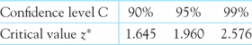
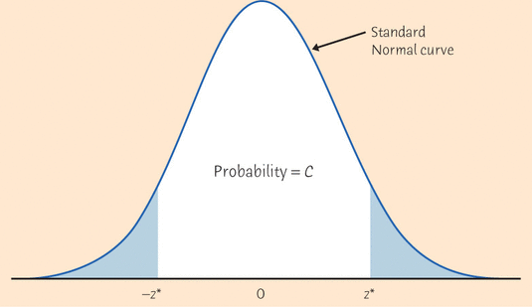
CONFIDENCE INTERVAL FOR THE MEAN OF A NORMAL POPULATION
Draw an SRS of size n from a Normal population having unknown mean µ and known standard deviation σ. A level C confidence interval for µ is $\overline{x}±z*\frac{σ}{\sqrt{n}}$, $z*\frac{σ}{\sqrt{n}}$ is called the margin or error.
Find a 80, 90, 95, 99% confidence interval for the mean BMI for women aged 20-29
The National Center for Health Statistics reports that the systolic blood pressure for males 35 to 44 years of age has mean 128 and standard deviation 15. The medical director of a large company looks at the medical records of 72 executives in this age group and finds that the mean systolic blood pressure in this sample is = 126.07. Find a 80, 90, 95, 99% confidence interval for the mean systolic bp for males aged 35 to 44.
Confidence intervals are one of the two most common types of statistical inference. Use a confidence interval when your goal is to estimate a population parameter. The second common type of inference, called tests of significance, has a different goal: to assess the evidence provided by data about some claim concerning a population. This is the topic of the next chapter.

