Class Notes – Chapter 15 – Sampling Distributions
A parameter is a number that describes the population. In practice when the population is large, the value of a parameter is unknown because we cannot examine the entire population. The mean of a population is denoted by $μ$ (the Greek letter mu)

A statistic is a number computed from sample data. In practice, we use a statistic to estimate an unknown parameter. The mean of a sample is denoted by $\overline{x}$.

Example: Florida has played a key role in recent presidential elections. Voter registration records show that 41% of Florida voters are registered as Democrats and 37% as Republicans. 250 randomly chosen Floridians are contacted and of these 33% are registered Democrats. Which of these numbers are parameters and which are statistics?

Statistical inference uses sample data to draw conclusions about the entire population. Even though $\overline{x}$ depends on the sample, if we keep taking larger and larger samples, the statistic $\overline{x}$ gets closer and closer to the parameter, $μ$. This is called the law of large numbers. The law of large numbers is the foundation of gambling casinos and insurance companies.

Sampling distributions:

The population distribution of a variable is the distribution of values of the variable among all the individuals in the population.

The sampling distribution of a statistic is the distribution of values taken by the statistic in all possible samples of the same size from the same population. This describes how the statistic varies in many samples from the population.

The following sampling distribution shows that histogram of the samples means of 1000 separate SRSs of size 10 is close to a Normal distribution

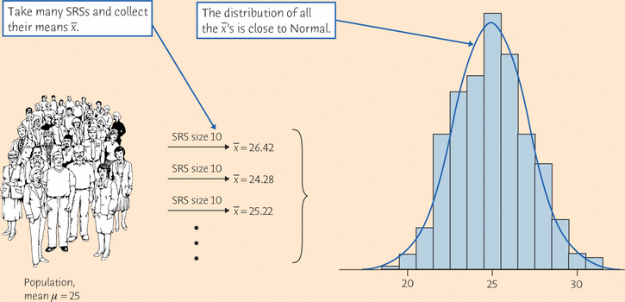
What can we say about the shape, center, and spread of this distribution?
- Shape: It looks Normal. Detailed examination confirms that the distribution of from many samples is very close to Normal.
- Center: The mean of the 1000 ’s is 24.95. That is, the distribution is centered very close to the population mean μ = 25.
- Spread: The standard deviation of the 1000 ’s is 2.217, notably smaller than the standard deviation σ = 7 of the population of individual subjects.
Although these results describe just one simulation of a sampling distribution, they reflect facts that are true whenever we use random sampling.
The Sampling Distribution of :
Sample mean, : Suppose that is the mean of an SRS of size n drawn from a large population with mean μ and standard deviation σ. Then the sampling distribution of has mean μ and standard deviation $σ/\sqrt{n}$. So the sampling distribution is less spread out than the distribution of individual observations because averages are less variable than individual observations.
If individual observations, $X$, have the N(μ, σ) distribution, then the sample mean of an SRS of size n has the N(μ, $σ/\sqrt{n}$) distribution.
CENTRAL LIMIT THEOREM
Draw an SRS of size n from any population with mean μ and finite standard deviation σ. The central limit theorem says that when n is large (accepted to be $n>30)$, the sampling distribution of the sample mean is approximately Normal:
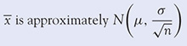
The central limit theorem allows us to use Normal probability calculations to answer questions about sample means from many observations even when the population distribution is not Normal.
15.14 The Bureau of Labor Statistics announces that last month it interviewed all members of the labor force in a sample of 60,000 households; 4.9% of the people interviewed were unemployed. The boldface number is a

(a) sampling distribution.
(b) parameter.
(c) statistic.
15.15 A study of voting chose 663 registered voters at random shortly after an election. Of these, 72% said they had voted in the election. Election records show that only 56% of registered voters voted in the election. The boldface number is a

(a) sampling distribution.
(b) parameter.
(c) statistic.

15.16 Annual returns on the more than 5000 common stocks available to investors vary a lot. In a recent year, the mean return was 8.3% and the standard deviation of returns was 28.5%. The law of large numbers says that

(a) you can get an average return higher than the mean 8.3% by investing in a large number of stocks.
(b) as you invest in more and more stocks chosen at random, your average return on these stocks gets ever closer to 8.3%.
(c) if you invest in a large number of stocks chosen at random, your average return will have approximately a Normal distribution.

15.17 Scores on the mathematics part of the SAT exam in a recent year were roughly Normal with mean 515 and standard deviation 114. You choose an SRS of 100 students and average their SAT math scores. If you do this many times, the mean of the average scores you get will be close to

(a) 515.
(b) 515/100 = 5.15.
(c) 515/√100 = 5.15.

15.18 Scores on the mathematics part of the SAT exam in a recent year were roughly Normal with mean 515 and standard deviation 114. You choose an SRS of 100 students and average their SAT math scores. If you do this many times, the standard deviation of the average scores you get will be close to

(a) 114.
(b) 114/100 = 1.14.
(c) 114/√100 = 11.4.

15.19 A newborn baby has extremely low birth weight (ELBW) if it weighs less than 1000 grams. A study of the health of such children in later years examined a random sample of 219 children. Their mean weight at birth was grams. This sample mean is an unbiased estimator of the mean weight μ in the population of all ELBW babies. This means that

(a) in many samples from this population, the mean of the many values of will be equal to μ.
(b) as we take larger and larger samples from this population, will get closer and closer to μ.
(c) in many samples from this population, the many values of will have a distribution that is close to Normal.

15.20 The number of hours a light bulb burns before failing varies from bulb to bulb. The distribution of burnout times is strongly skewed to the right. The central limit theorem says that

(a) as we look at more and more bulbs, their average burnout time gets ever closer to the mean μ for all bulbs of this type.
(b) the average burnout time of a large number of bulbs has a distribution of the same shape (strongly skewed) as the distribution for individual bulbs.
(c) the average burnout time of a large number of bulbs has a distribution that is close to Normal.

15.21 The length of human pregnancies from conception to birth varies according to a distribution that is approximately Normal with mean 266 days and standard deviation 16 days. The probability that the average pregnancy length for 6 randomly chosen women exceeds 270 days is about

(a) 0.40.
(b) 0.27.
(a) 0.07.

Bottom of Form

