Chapter 14
THE BINOMIAL SETTING, very common setting
- There are a fixed number, n, of observations.
- The n observations are all independent. That is, knowing the result of one observation does not change the probabilities we assign to other observations.
- Each observation falls into one of just two categories, which for convenience we call “success” and “failure.”
- The probability of a success, call it p, is the same for each observation.

BINOMIAL DISTRIBUTION- special case of a discrete random variable.
- The count X of successes in a binomial setting has the binomial distribution with parameters n and p, where n is the number of trials of the chance process and p is the probability of a success on any one trial. The possible values of X are the whole numbers from 0 to n.
- If X is Binomial, with n fixed trials and a constant probability of success, p, on each trial, then the formulas for the mean and standard deviation are:
$$μ=n*p, and σ=\sqrt{n*p(1-p)}$$
Common notation is : X~B(n,p)
- If X has the binomial distribution with n trials and probability p of success on each trial, the possible values of X are 0, 1, 2, …, n. If k is any one of these values, then
P(X=k)= the probability that outcome k occurs=probability that X is exactly k =
$\left(\begin{matrix}n \\ k\end{matrix}\right)p^{k}{\left(1-p\right)}^{n-k}$, where $\left(\begin{matrix}n \\ k\end{matrix}\right)=\frac{n!}{k!*\left(n-k\right)!}$
$n$!=n(n-1)*(n-2)*(n-3)*…*1 , 10!= 10*9*8*7*6*5*4*3*2*1, (10-2)!=8!=8*7*6*5*4*3*2*1
Note that P(X=k)=$\left(\begin{matrix}n \\ k\end{matrix}\right)p^{k}{\left(1-p\right)}^{n-k}$=binompdf(n,p,k) using the distribution button in your calculator.
- P(X≤k)=binomcdf(n,p,k)
You can use these (1-3) if you recognize the binomial setting and can identify n and p. Note that for some problems, you will need to also incorporate some of the probability rules.
Examples of a binomial setting:
X counts the number of heads in 10 tosses of a fair coin. 2 outcomes, Success= heads, n=10, p=0.5, outcome of each trial independent.
An NBA professional basketball player counts the number of free throws he makes in 10 attempts. His record is 80%. 2 outcomes, Success = make a free throw, n=10, p=0.8, can assume chance of making each one is .8 (independent).
Another type of binomial setting-Sampling Distribution of a Count: Choose an SRS of size n from a population with proportion p of successes. When the population is much larger than the sample, the count X of successes in the sample has approximately the binomial distribution with parameters n and p.
If 80% of the population of Tucson supports a ban on smoking in public, then if you choose an SRS of size 100 and count the number who support the ban, you have meet the binomial setting: 2 outcomes, success=count of individuals who support the ban, n=100, p=.8, each person’s response is independent of the others.
Examples where binomial conditions are not met:
Toss a fair coin until you get 10 heads. Problem: n is not fixed.
Choose 10 cards without replacement and count the number of red cards. Problem: no constant probability of “success”, or red card.
80% of the population have high blood sugar. You take an SRS of size 100 and record the person’s blood sugar. Problem: more than 2 outcomes. What is a success?
A normal blood sugar level two hours after eating is less than 140 mg/dL. You stand outside of Old Main and randomly select students 100 to have their blood sugar checked after eating. Each of the 100 you select participates. You count the number who have blood sugar above 140mg/dL. Problems: not an SRS, p may not be constant (how do you know if ate 2 hours ago? )

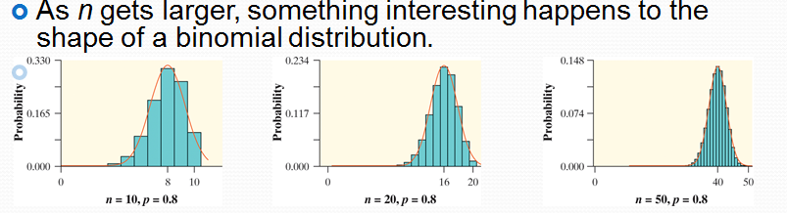
NORMAL APPROXIMATION FOR BINOMIAL DISTRIBUTIONS
Suppose that a count X has the binomial distribution with n observations and success probability p. When n is large, the distribution of X is approximately Normal, $\left(np,\sqrt{np\left(1-p\right)}\right)$ .
As a rule of thumb, we will use the Normal approximation when n is so large that np ≥ 10 and n(1 – p) ≥ 10. This means that you can use normcdf(a,b,$np,\sqrt{np\left(1-p\right)}$) to estimate probabilities.

Some worked problems:
