WS32bR Answer Key Review for Test ___ Section 4.4 -7.1 134
For 2a you can do algebra to find the answer if 7.1 has not be taught yet.
For 2j graph the function to answer the question.
L
Error below the t’s should be x’s

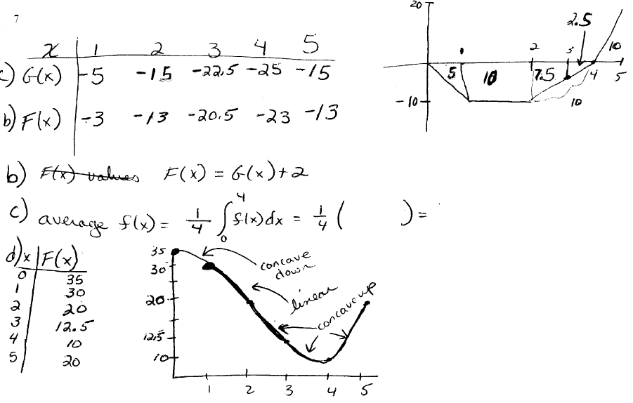

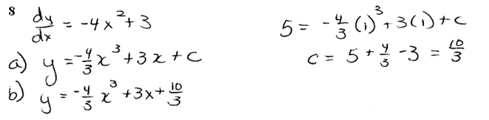

9. Estimate (usually means using AllSums program)
a) $\int_{0}^{\frac{π}{2}}{{\left(\sin\left(x\right)\right)}^{x}dx}$
Tried to use the Allsum program with a=0, b= π/2 and n= 250
Since the lower limit value does not exist, an error occurred.
$\int_{0.001}^{\frac{π}{2}}{{\left(\sin\left(x\right)\right)}^{x}dx}$ Use Allsum program a= .001 b=π/2 and n = 100
LHS = 1.284 RHS = 1.284

b) $\int_{0}^{4}{\frac{e^{x}}{1+e^{2x}}dx}$ Using All sums program with a= 0, b=4 and n = 100
LHS = .7767 RHS = .7574
Best estimate of the integral is (LHS+RHS)/2= .76705

10. a) $\frac{d}{dx}\int_{0}^{x}{\sin\left(t^{2}\right)dt }=\sin\left(x^{2}\right)$
b) $\frac{d}{dx}\int_{x}^{1}{\ln\left(t\right)dt }= \frac{d}{dx}-\int_{1}^{x}{\ln\left(t\right)dt }=-\ln\left(x\right)$
c) $\frac{d}{dx}\int_{1}^{x^{3}}{{\left(1+t\right)}^{5}dt}={\left(1+x\right)}^{5}(3x^{2})$
d) $\frac{d}{dx}\left(3xSi\left(x\right)\right)=\frac{d}{dx}\left(3x\right)Si\left(x\right)+3x(\frac{d}{dx}\left(Si\left(x\right)\right)=3Si\left(x\right)+3x\left(\frac{\sin\left(x\right)}{x}\right)=3Si\left(x\right)+3\sin\left(x\right)$

11. This is related rates
Draw a picture. The angle between the wall and the top of the ladder is $θ$
The ladder is 12 ft. The length on the ground is $x$.
The rate of change of the ladder horizontally is $\frac{dx}{dt}=4\frac{ft}{sec}.$
Find $\frac{dθ}{dt}{\left.​\right|}_{θ=\frac{π}{6}}$ ??
Set up:
$sinθ=\frac{x}{12}$
When $θ=\frac{π}{6}$ then $\sin\left(\frac{π}{6}\right)=\frac{1}{2}=\frac{x}{12}$ therefore $x=6$
Here are two possible methods on finding the rate of change of theta.
Method 1 Method 2
$\sin{θ=\frac{x}{12}}$ $\sin{θ=\frac{x}{12}}$
$θ=arcsin⁡\left(\frac{x}{12}\right)$ $\cos{θ\frac{dθ}{dt}=\frac{1}{12}*\frac{dx}{dt}}$
$\frac{dθ}{dt}=\frac{1}{\sqrt{1-{\left(\frac{x}{12}\right)}^{2}}}*\frac{1}{12}*\frac{dx}{dt}$ $\cos\left(\frac{π}{6}\right)=\frac{\sqrt{3}}{2}$
$\frac{dθ}{dt}=\frac{1}{\frac{1}{12}\sqrt{144-x^{2}}}*\frac{1}{12}*(4)$ $\frac{\sqrt{3}}{2}*\frac{dθ}{dt}{\left.​\right|}_{θ=\frac{π}{6}}=\frac{1}{12}*(4)$
$\frac{dθ}{dt}=\frac{4}{\sqrt{144-x^{2}}}$ $\frac{dθ}{dt}{\left.​\right|}_{θ=\frac{π}{6}}=\frac{2}{3\sqrt{3}}$

Now evaluating when $=\frac{π}{6}$ ; $x=6$
$$\frac{dθ}{dt}{\left.​\right|}_{θ=\frac{π}{6}}=\frac{4}{\sqrt{144-6^{2}}}$$
$$\frac{dθ}{dt}{\left.​\right|}_{θ=\frac{π}{6}}=\frac{4}{\sqrt{108}}=\frac{4}{6\sqrt{3}}$$
$$\frac{dθ}{dt}{\left.​\right|}_{θ=\frac{π}{6}}=\frac{2}{3\sqrt{3}}$$
The angle is changing at a rate of $\frac{2}{3\sqrt{3}} ≈.3849$ radians per second.
15. (This is from section 4.7) $\frac{1}{7}$, 0, 0, 8
16. $\frac{1}{2}x^{4}+\frac{2}{9}x^{\frac{9}{2}}+c$
17. 4
18. $-\frac{2}{15}{\left(5-2y\right)}^{\frac{3}{4}}+c$
19. 46° This is a differential equation.
20. $K=50/333$ (use algebra first to solve)

