Express the area of a circle as a function of its circumference c.

The height of a soda can is twice its diameter. Write the surface area as a function of the radius.

The volume of a right circular cylinder is 25 cm³, express the surface area S as a function of the radius r.
An open-top crate with square base is to be constructed from two materials: one for the bottom and one for the sides. The volume of the box is to be 6 cubic feet. The cost of the material for the bottom is $3 per square foot, and the cost of the material for the sides is $2 per square foot.
Determine a model for the cost of constructing the box as a function of its height h.
What is the domain of this function?

An underground telephone line is to be installed from a new house to the nearest junction box. The house is 50 meters from the main road, and the junction box is 180 meters down the road.
Determine a model for the length of the line as a function of the distance x the line is laid along the road.
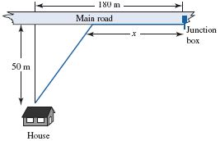

Suppose that in the last example the installation cost of the line is $3 per meter along the road and $4 per meter off the road.
Determine a model for the total cost of installing the line as a function of the distance x the line is laid along the road.

Alaina wants to get to the bus stop as quickly as possible. The bus stop is across a grassy park, 2000 feet west and 600 feet north of her starting position. Alaina can walk west along the edge of the park on the sidewalk at a speed of 6 ft/sec. She can also travel through the grass in the park, but only at a rate of 4 ft/sec. Write the time it takes her to get to the bus stop as a function of the distance she walks across the sidewalk.

A landscape architect plans to enclose a 3000 square foot rectangular region in a botanical garden. She will use shrubs costing $25 per foot along 3 sides and fencing costing $10 per foot along the fourth side. Write a function which represents the total cost as a function of the length of the fence l.

A water trough 8 feet long is constructed in such a way that the ends are isosceles triangles and the sides are rectangles that are 8 feet by 4 feet. Express the volume as a function of the width across the top.
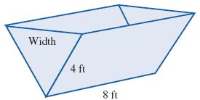

Water is poured into a conical tank at a rate of 24 cubic feet per hour. The tank is 12 feet high, and the top radius is 6 feet. Express the depth of the water as a function of the number of hours the water has been pouring into the tank.
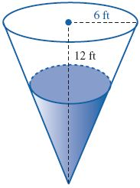

A rectangular exhibit is to be roped off with 130 feet of rope. An existing 14 foot wall is to be used as part of the boundary.
a) Determine a model for the area as a function of x.
b) What is the maximum area of the exhibit?
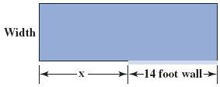

Dennis the mad scientist is so infuriated by not being able to get his desired result from his latest experiment that he decides to throw it off the top of an 80 foot tall building. The (evil) experiment’s height h (in feet) above ground level t seconds after it is thrown is given by the function
$$h\left(t\right)=-16t^{2}+40t+80$$
What is the maximum height the ball reaches?
How long does it take the ball to reach that height?

Two numbers sum to 26. What is the largest possible value for their product?

A farmer has 800 yards of fencing with which to build two adjacent rectangular corrals. The two corrals are to share a common fence on one side. Find the dimensions so that the area of the pens is as large as possible.

Suppose that the following demand function relates the selling price, p, of an item to the quantity sold, q:
$$p=-\frac{1}{3}q+40$$
What is the maximum revenue from selling this product? How many units should be sold to achieve this revenue?

A fence 8 ft tall runs parallel to a tall building at a distance of 4 ft from the building. What is the length of the shortest ladder that will reach from the ground over the fence to the wall of the building?

